Healthy Heads & SuperFriend TWI Survey Campaign –

6-Month Email Campaign Sequence

Ready-to-Send Email Templates
If you communicate with your team or wider stakeholders via email, we’ve made promotion easy. We’ve developed a suite of ready-to-send email templates you can quickly customise and distribute to support the survey rollout. These clear, engaging messages are designed to build awareness, reinforce key messages, and drive participation, helping to maximise response rates. Simply tailor, schedule, and send.
*Tip: If you would like to add a graphic image to your email, use one of the social media tiles provided in this Marketing Kit.
-------------------------------------------

Email 1 – Launch Announcement
Timing:
26 February
Subject Line:
The TWI Survey is Now Open – Help Shape the Future of Wellbeing!
Body:
The Thriving Workplace Index (TWI) survey is now open! Healthy Heads and SuperFriend are calling on everyone in the transport and logistics industry to share their insights.
Key Insight: Transport and warehousing workers experience persistently higher psychological risk than other industries, with ongoing pressures linked to stress, burnout, and turnover
By completing the survey, you help capture the real experiences of people working in frontline roles, providing insights that can drive long-term, meaningful change.
Encourage your teams, colleagues, and stakeholders to participate. The more responses we receive, the stronger the insights and the greater the impact on workforce wellbeing.
TWI survey: https://www.surveymonkey.com/r/HHTS1
Marketing Kit: https://www.healthyheads.org.au/resources-and-training/resource-portal/?_resource_category=twi-survey
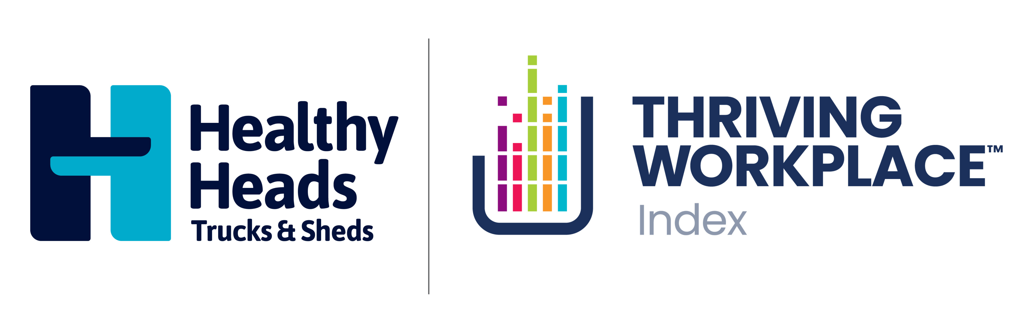
-------------------------------------------
Email 2 – Reminder & Benefits
Timing:
26 March
Subject Line:
Your Voice Matters – TWI Survey Reminder
Body:
Thank you to those who have already participated! If you haven’t yet, now’s the time to share your experience.
Key Insight: Disconnection, isolation, and leadership gaps are dominant drivers of poor mental health in transport and logistics. Only 69% of those in the industry feel that people genuinely care about each other at work.
Your responses will help identify ways to rebuild connection, improve leadership capability, and create a more supportive workplace.
TWI survey: https://www.surveymonkey.com/r/HHTS1
Marketing Kit: https://www.healthyheads.org.au/resources-and-training/resource-portal/?_resource_category=twi-survey
-------------------------------------------

Email 3 – Mid-Campaign Engagement
Timing:
26 April
Subject Line:
Help Shape a Thriving Transport Industry
Body:
Halfway through our 6-month survey window! Every response matters.
Key Insight: People working in transport and logistics report that current work design and safety systems prioritise operations over people. Only 50% feel safe to speak up, and just 54% believe their organisation is mentally healthy.
By participating, you will help highlight opportunities and inform work systems that treat mental health as non-negotiable, supporting both safety and wellbeing.
Need resources to help promote the survey? Our marketing kit is ready to go.
TWI survey: https://www.surveymonkey.com/r/HHTS1
Marketing Kit: https://www.healthyheads.org.au/resources-and-training/resource-portal/?_resource_category=twi-survey
-------------------------------------------

Email 4 – Spotlight on Impact / Testimonials
Timing:
26 May
Subject Line:
See How Your Industry Colleagues Are Driving Change
Body:
Hundreds of people working across diverse roles in transport and logistics have contributed to the TWI survey. Their insights are helping to inform practical solutions to improve workplace wellbeing.
Key Insight: Real change starts with connection. Structured peer connection, visible leaders, and everyday human interaction can significantly reduce isolation for drivers and warehouse teams.
Join your colleagues and make your voice heard. The more responses, the stronger the impact.
TWI survey: https://www.surveymonkey.com/r/HHTS1
Marketing Kit: https://www.healthyheads.org.au/resources-and-training/resource-portal/?_resource_category=twi-survey
-------------------------------------------

Email 5 – Final Push
Timing:
26 June
Subject Line:
Last Chance to Participate – Make Your Voice Count
Body:
Time is running out! The first TWI survey data analysis starts soon. Don’t miss your chance to contribute to this important industry-wide research.
Key Insight: Leadership capability directly shapes trust, safety, and help-seeking. Role-specific, practical leadership development ensures leaders model positive mental health behaviours and actively support staff.
Share the survey with your teams, colleagues, and networks. Every response matters!
TWI survey: https://www.surveymonkey.com/r/HHTS1
Marketing Kit: https://www.healthyheads.org.au/resources-and-training/resource-portal/?_resource_category=twi-survey
-------------------------------------------

Email 6 – Closing Reminder
Timing:
26 July
Subject Line:
Final Call – Build a Thriving Industry
Body:
This is your last opportunity to have your say in the transport and logistics Thriving Workplace Index.
Key Insight: Redesigning work and safety systems to treat mental health as non-negotiable is essential for sustainable performance and retention. Your insights will help inform future design of workplace wellbeing programs and resources.
Don’t wait — make your voice count!
TWI survey: https://www.surveymonkey.com/r/HHTS1
Marketing Kit: https://www.healthyheads.org.au/resources-and-training/resource-portal/?_resource_category=twi-survey

