Social Media Copy - Promotion of Thriving Workplace Index Survey

Prepared Social Media Content
If you use social media to connect with your workforce or broader network (members, tenants, customers), we’ve made promotion simple. We’ve developed ready-written social media copy that you can quickly post across your channels to build awareness and encourage survey participation. To make it even easier, branded social media tiles have been created and are available in the marketing kit, giving you everything you need to maximise reach.

Post 1 – Launch Announcement
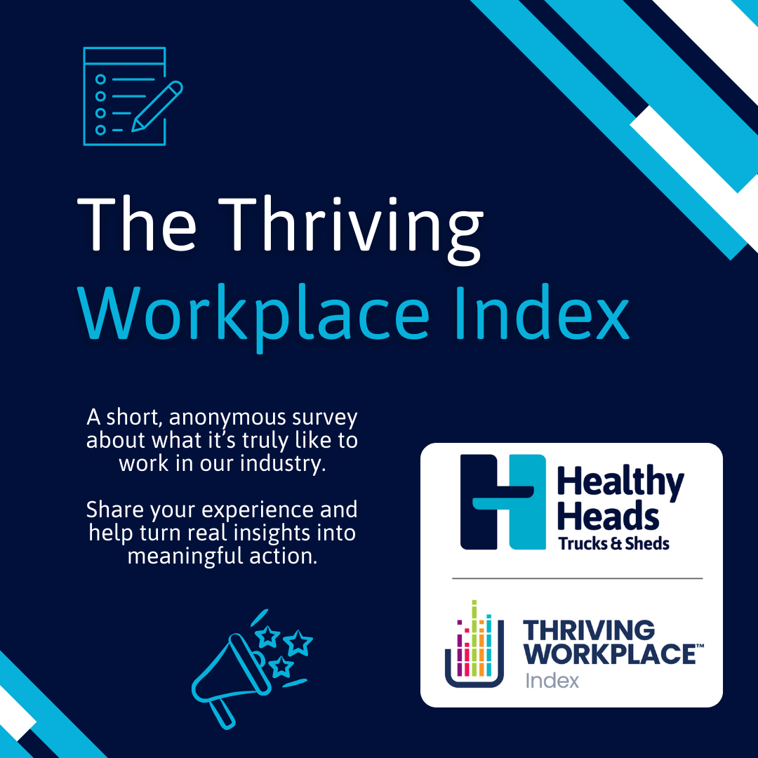
LinkedIn:
The transport and logistics Thriving Workplace Index (TWI) survey is now OPEN!
Healthy Heads and SuperFriend are calling on everyone in the industry to share their insights.
Key Insight: Transport and warehousing workers face persistently higher psychological risk than other industries, with ongoing pressures contributing to stress, burnout, and turnover.
Your voice matters! The more responses we get, the stronger the insights to drive real change in workforce wellbeing.
Survey: https://www.surveymonkey.com/r/HHTS1
Marketing Kit: https://www.healthyheads.org.au/resources-and-training/resource-portal/?_resource_category=twi-survey
#HealthyHeads #ThrivingWorkplace #TransportWellbeing #WorkplaceMentalHealth #LogisticsWellbeing

Facebook:
The transport and logistics TWI survey is now open!
People across transport and logistics experience higher stress and burnout than most industries. We need your input to change that.
Take the survey, share with your team, and help shape a healthier, safer workplace. 💪
Survey: https://www.surveymonkey.com/r/HHTS1
Marketing Kit: https://www.healthyheads.org.au/resources-and-training/resource-portal/?_resource_category=twi-survey
#HealthyHeads #ThrivingWorkplace #MentalHealth #TransportAndLogistics

Post 2 – Reminder & Benefits
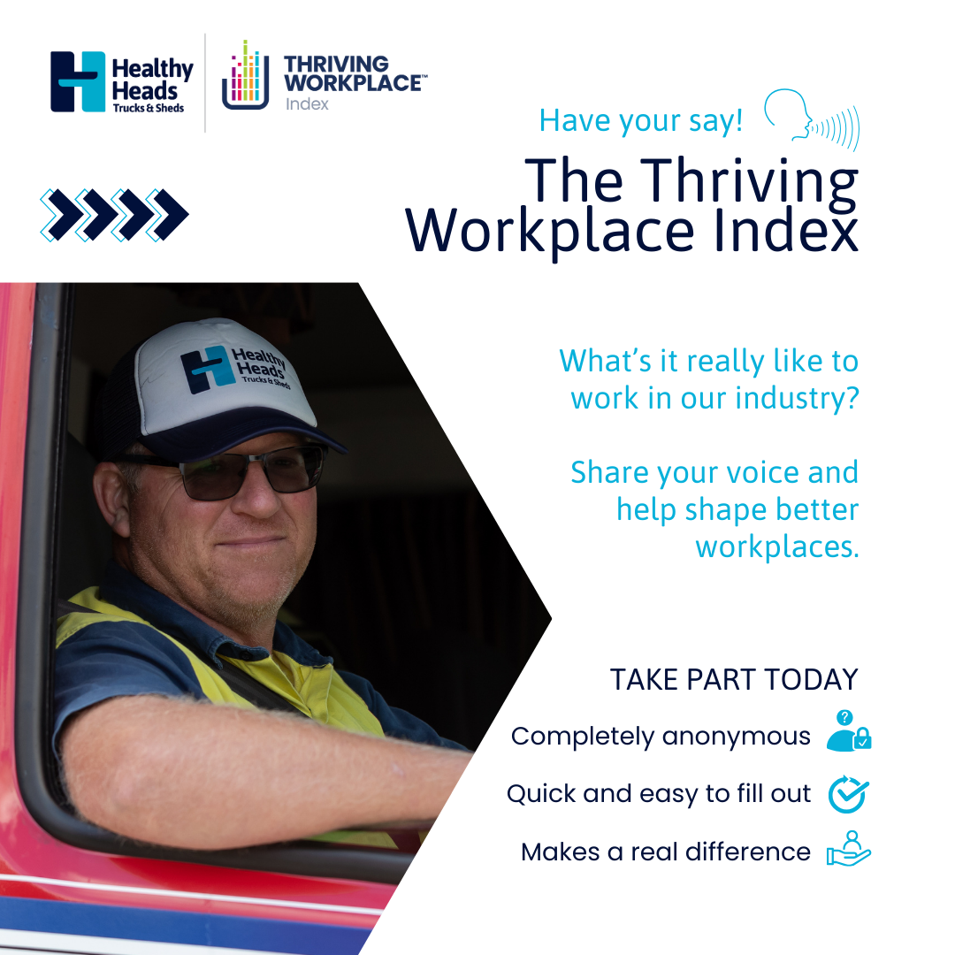
LinkedIn:
Have you completed the transport and logistics TWI survey yet?
Key Insight: Disconnection, isolation, and leadership gaps are major drivers of poor mental health in our industry. Only 69% in the industry feel people care about each other at work.
Your insights can help rebuild connection, improve leadership, and create safer workplaces for everyone.
🔗 https://www.surveymonkey.com/r/HHTS1
#TransportWellbeing #ThrivingWorkplace #MentalHealthMatters #HealthyHeads

Facebook:
Reminder! If you haven’t taken the TWI survey yet, now’s your chance. 📝
Isolation and leadership gaps are hurting our workforce. Your feedback can help create stronger, more connected teams.
🔗 https://www.surveymonkey.com/r/HHTS1
#ThrivingWorkplace #MentalHealth #TransportAndLogistics #HealthyHeads

Post 3 – Mid-Campaign Engagement
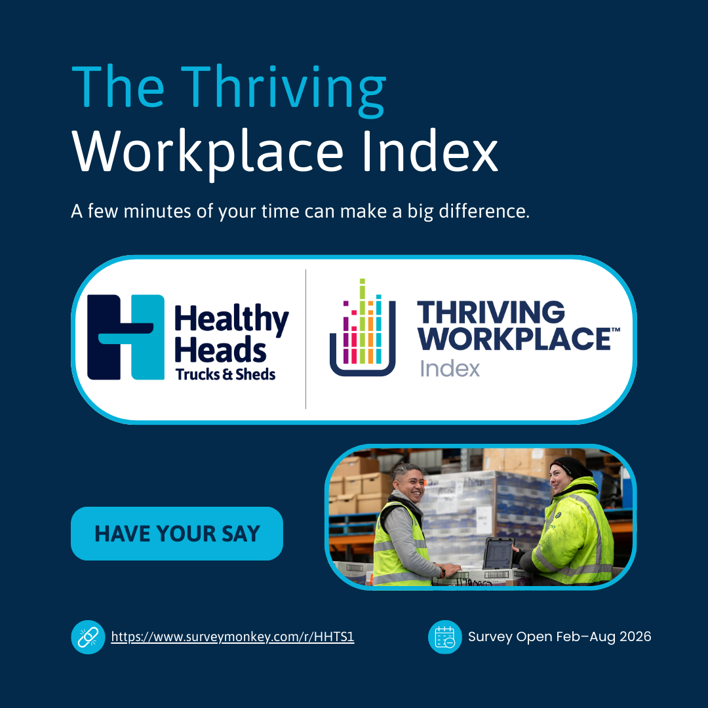
LinkedIn:
We’re halfway through the TWI survey period! Every voice counts.
Key Insight: People working in transport and logistics say work design and safety systems currently prioritise operations over people. Only 50% feel safe to speak up, and just 54% believe their workplace is mentally healthy.
Help us identify opportunities to redesign workplaces where mental health is treated as non-negotiable.
Survey: https://www.surveymonkey.com/r/HHTS1
#ThrivingWorkplace #MentalHealthAwareness #HealthyHeads #TransportAndLogistics

Facebook:
Halfway there! Have you shared your voice in the TWI survey yet?
Right now, work systems often prioritise operations over people. Your input will help make workplaces safer, healthier, and more supportive.
Survey: https://www.surveymonkey.com/r/HHTS1
#ThrivingWorkplace #MentalHealth #HealthyHeads

Post 4 – Spotlight on Impact / Testimonials
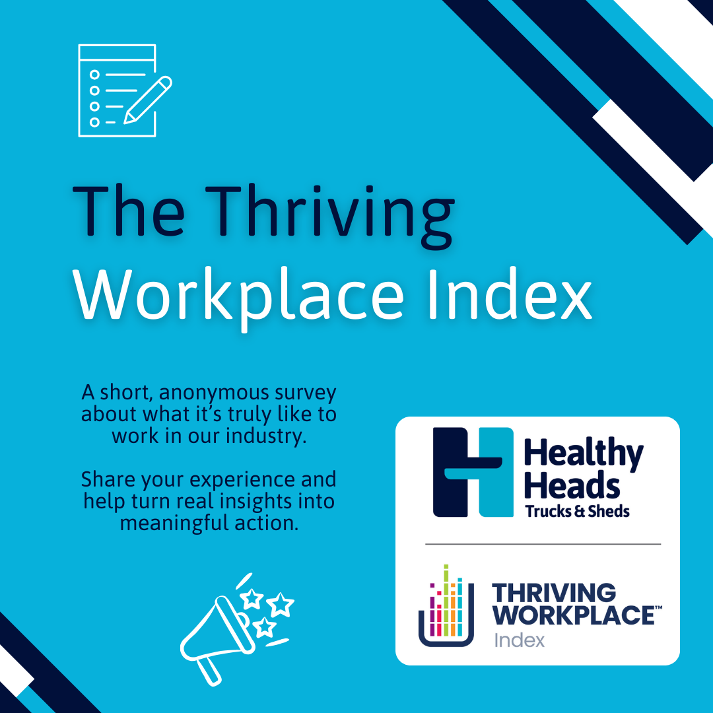
LinkedIn:
Hundreds of people across transport and logistics have already contributed to the industry’s first TWI survey.
Key Insight: Real change starts with connection. Structured peer connection, visible leaders, and everyday human interaction can reduce isolation for drivers and people working in warehouses and across logistics.
Join your colleagues. Make your voice heard and help shape practical wellbeing solutions across the industry.
Survey: https://www.surveymonkey.com/r/HHTS1
#ThrivingWorkplace #MentalHealth #Leadership #HealthyHeads

Facebook:
Connections make the difference!
The transport and logistics TWI survey shows that visible leaders and peer support can reduce isolation for drivers and people working across transport and logistics. Share your experience and help us create a more connected, resilient industry.
Survey: https://www.surveymonkey.com/r/HHTS1
#ThrivingWorkplace #MentalHealth #HealthyHeads

Post 5 – Final Push
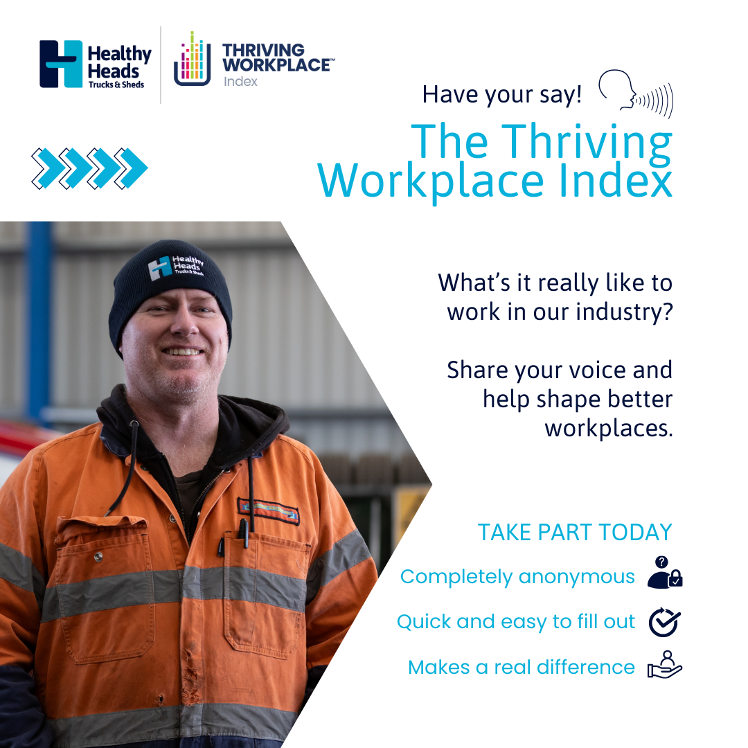
LinkedIn:
Time is running out! The TWI survey data analysis will commence soon.
Key Insight: Leadership directly shapes trust, safety, and help-seeking. Practical, role-specific development ensures leaders model positive mental health behaviours.
Don’t miss your chance to contribute to safer, more supportive workplaces.
Survey: https://www.surveymonkey.com/r/HHTS1
#ThrivingWorkplace #HealthyHeads #Leadership #MentalHealth

Facebook:
Final call!
Leaders play a huge role in workplace wellbeing. Your feedback will help shape training, support, and culture in transport and logistics. Take the TWI survey before it closes.
Survey: https://www.surveymonkey.com/r/HHTS1
#ThrivingWorkplace #MentalHealth #HealthyHeads

Post 6 – Closing Reminder
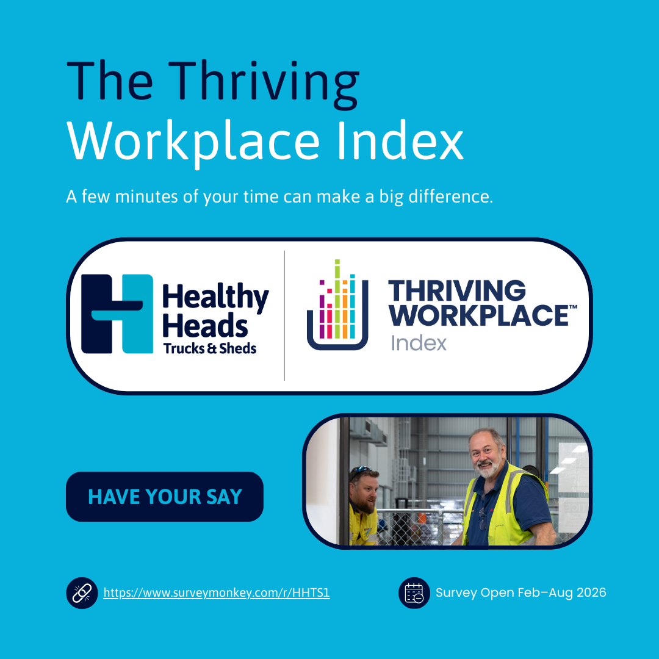
LinkedIn:
Last chance to participate in the transport and logistics TWI survey!
Key Insight: Redesigning work and safety systems to treat mental health as non-negotiable is essential for sustainable performance and retention. Your input will help co-design safer, healthier workplaces.
Make your voice count!
Survey: https://www.surveymonkey.com/r/HHTS1
#ThrivingWorkplace #HealthyHeads #MentalHealthMatters #TransportAndLogistics

Facebook:
Get in quick!
Help us redesign work and safety systems to prioritise mental health. Take the transport and logistics TWI survey and make your voice count before it closes.
Survey: https://www.surveymonkey.com/r/HHTS1
#ThrivingWorkplace #HealthyHeads #MentalHealth #TransportAndLogistics

